# SQL Technical

Load these files into a SQL database. Double click the icons below to open them.



Provide the SQL Statement for each of the questions below.

## Question 1: Simple Ranking

Top 5 customers sales who purchased product category “Phones”.

**SELECT TOP 5 c.NAME AS CUSTOMER_NAME**

**,sum(o.SALES) AS SALE**

**FROM Orders o**

**INNER JOIN Customer c ON o.CUSTOMER_ID = c.ID**

**INNER JOIN Product p ON o.PRODUCT_ID = p.ID**

**WHERE p.CATEGORY = 'Phones'**

**GROUP BY c.NAME**

**ORDER BY SALE DESC**

Results:

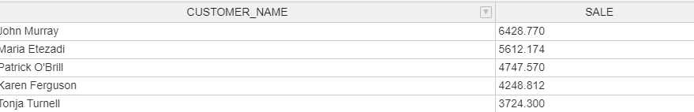

## Question 2: Ranking Within a Group

Top 2 customers sales per product category.

**SELECT new.CUSTOMER_NAME**

**,new.CATEGORY**

**,new.SALE**

**,new.RANK**

**FROM (**

**SELECT c.NAME AS CUSTOMER_NAME**

**,p.CATEGORY**

**,sum(o.SALES) AS SALE**

**,rank() OVER (**

**PARTITION BY p.CATEGORY ORDER BY sum(o.SALES) DESC**

**) AS RANK**

**FROM Orders o**

**INNER JOIN Customer c ON o.CUSTOMER_ID = c.ID**

**INNER JOIN Product p ON o.PRODUCT_ID = p.ID**

**GROUP BY c.NAME**

**,p.CATEGORY**

**) AS new**

**WHERE new.RANK <= 2**

Results:

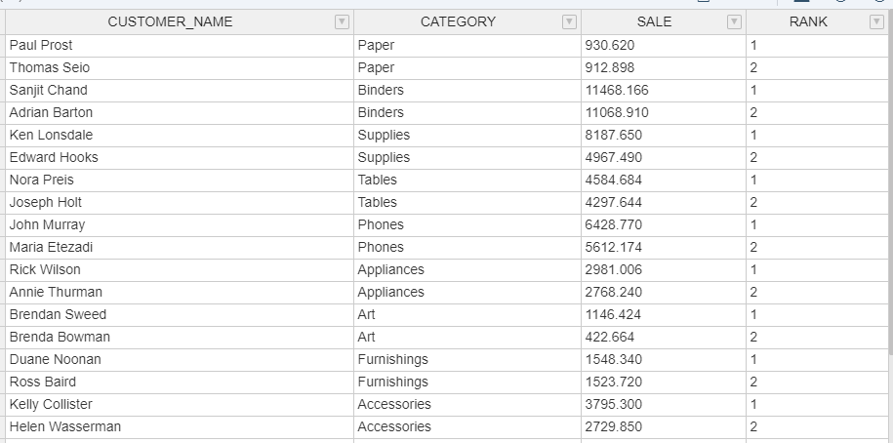

## Question 3: Percentage Distribution

Total sales by product category and the contribution against total sales.

**SELECT p.CATEGORY**

**,sum(o.SALES) AS SALE**

**,round((**

**100 * sum(o.SALES) / (**

**SELECT sum(SALES)**

**FROM Orders**

**)**

**), 2) AS '%'**

**FROM Orders o**

**INNER JOIN Customer c ON o.CUSTOMER_ID = c.ID**

**INNER JOIN Product p ON o.PRODUCT_ID = p.ID**

**GROUP BY p.CATEGORY**

**ORDER BY SALE DESC**

Results:

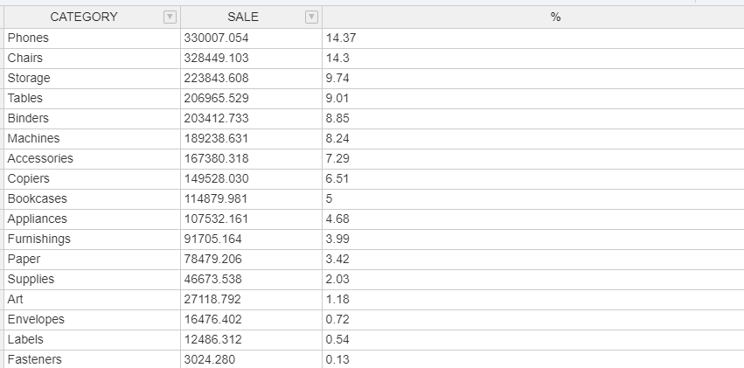

## Question 4: Whole Number Allocation

You have a product distribution as below.

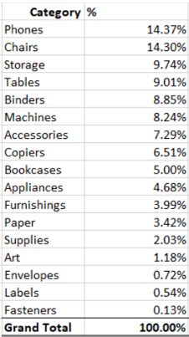

You are required to spread a fixed value of 2,000 across all product based on this distribution percentage. However, the spread of these number needs to be in whole number and not decimal point. The sum of all this product must add up to exactly **2,000**.

**SELECT p.CATEGORY**

**,sum(o.SALES) AS SALE**

**,round((**

**sum(o.SALES) / (**

**SELECT sum(SALES)**

**FROM Orders**

**)**

**), 4) AS '%'**

**,round((**

**round((**

**sum(o.SALES) / (**

**SELECT sum(SALES)**

**FROM Orders**

**)**

**), 4) * 2000**

**), 0) AS Spread**

**FROM Orders o**

**INNER JOIN Customer c ON o.CUSTOMER_ID = c.ID**

**INNER JOIN Product p ON o.PRODUCT_ID = p.ID**

**GROUP BY p.CATEGORY**

**ORDER BY SALE DESC**

Results:

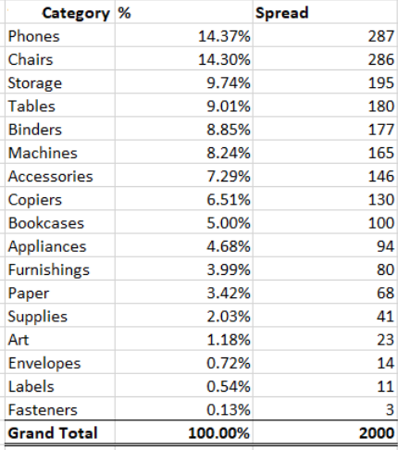

## Question 5: Basket Data

What are the 2 most common products purchased together in an order?

**SELECT c.PRODUCT_1**

**,c.PRODUCT_2**

**,count(*) AS COUNT**

**FROM (**

**SELECT a.PRODUCT_ID AS PRODUCT_1**

**,b.PRODUCT_ID AS PRODUCT_2**

**FROM Orders a**

**INNER JOIN Orders b ON a.ORDER_ID = b.ORDER_ID**

**AND a.PRODUCT_ID != b.PRODUCT_ID**

**) c**

**GROUP BY c.PRODUCT_1**

**,c.PRODUCT_2**

**ORDER BY COUNT DESC**

Results:

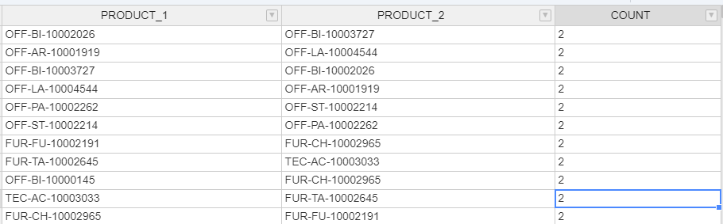

Questions for Data Visualization

Order

* What’s our overall profit/sales over different years?
* What’s the trend of profit/sales?
* What’s the trend of the number of orders?
* What’s the effectiveness of discount on sales? What’s the relationship between discount and sales?

Product

* Which product category has great sales/profit?
* Which product is profitable? Which product is making loss?
* What’s the trend of profit on our product?

Customer

* Who are our profitable customers?
* Which customer segment has great sales/profit?
* Where do our profitable customers locate? Which state has great profit?
* What’s the demand of the ship mode?